ARCHITECTURE FOR OUR APP:

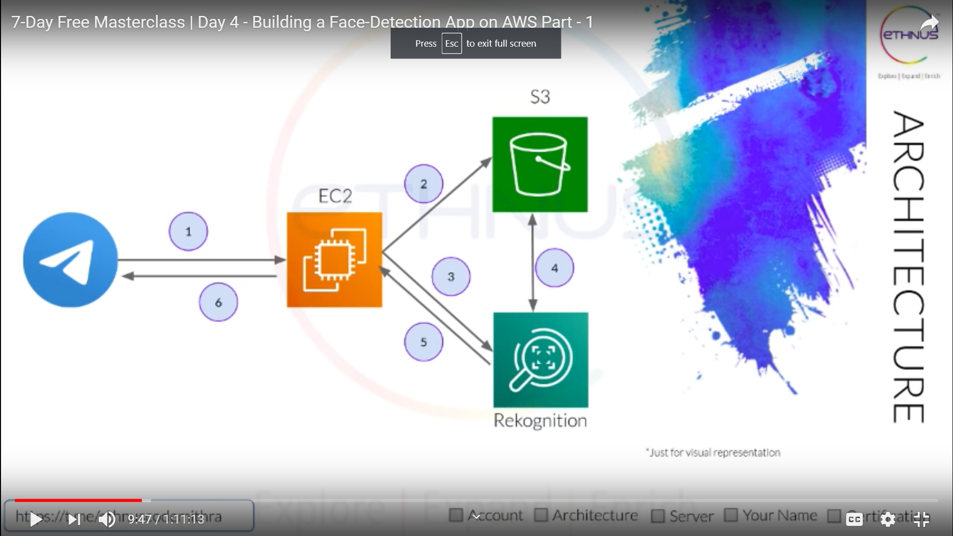

SETTING UP AN EC2 INSTANCE:  
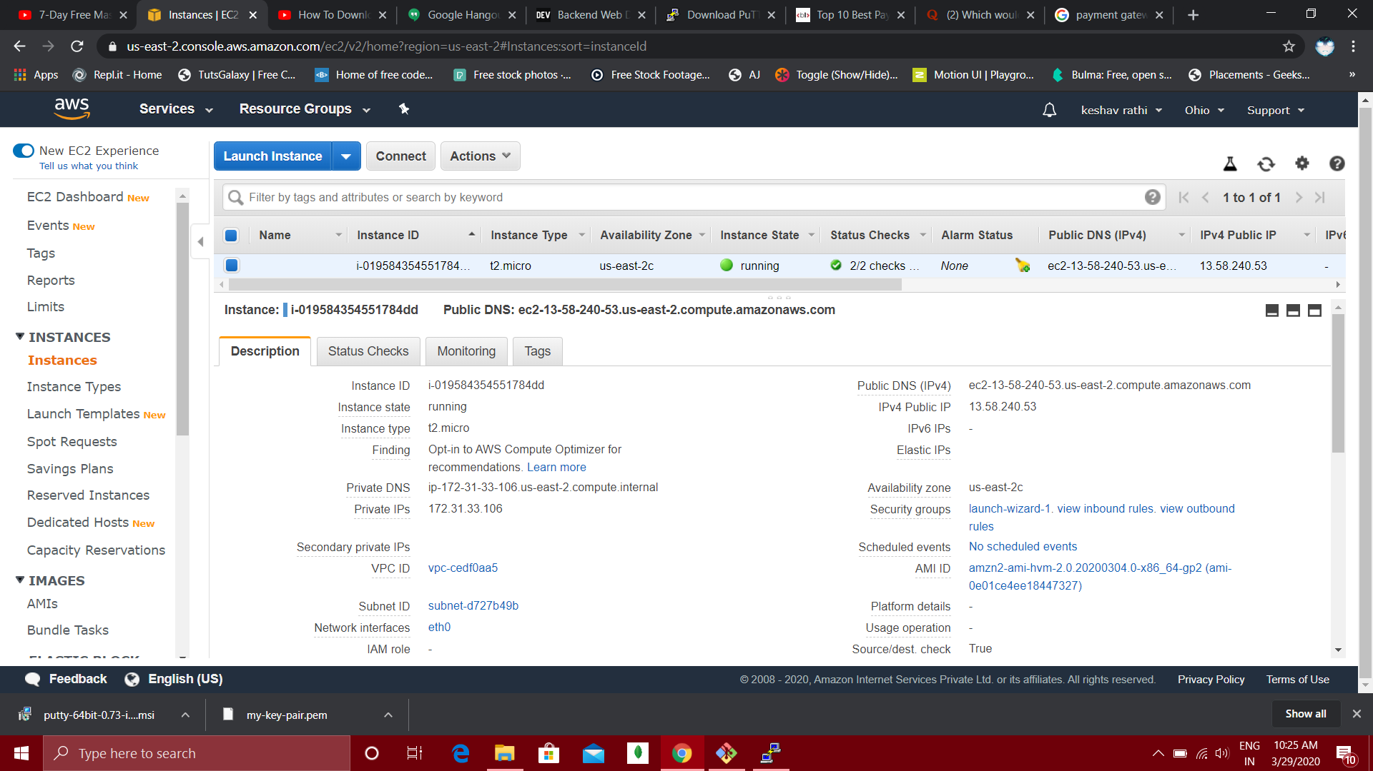

1. SELECT AMAZON LINUX 2 AMI(FREE TIER)(OPERATING SYSTEM)
2. FOR INSTANCE TYPE CHOOSE T2.MICRO
3. CONFIGURE INSTANCE DETAILS KEEP AS IT IS
4. ADD STORAGE OPTION CHECK FOR FREE TIER ELIGIBLE TAG IF IT IS THEN YOU ARE GOOD TO GO
5. ADD TAG SECTION KEEP AS IT IS
6. CONFIGURE SECURITY GROUP:

TYPE SSH TCP PORT 22(IE, ALLOW PORT 22 TRAFFIC ONLY)

1. REVIEW

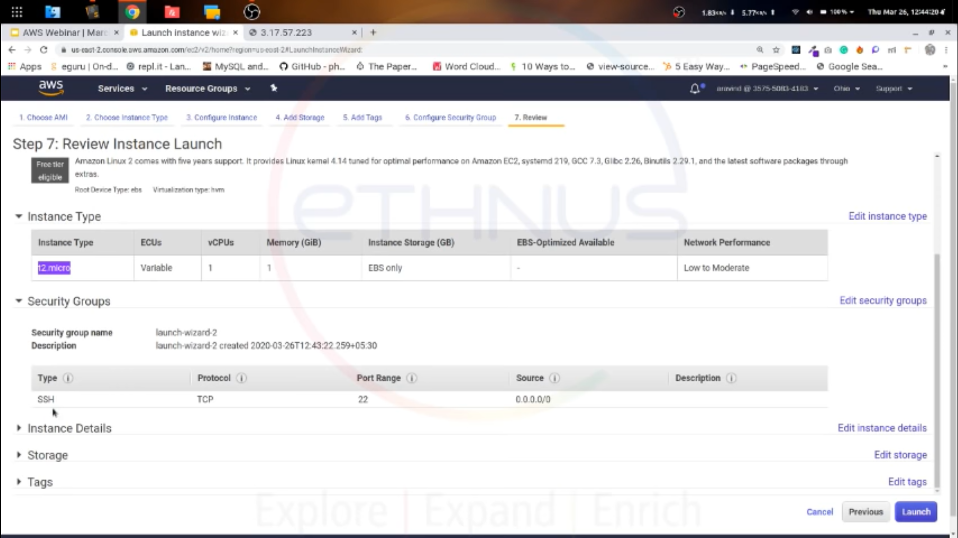

1. GIVE KEY PAIR NAME AND DOWNLOAD THE KEY, A .PEM FILE WILL BE DOWNLOADED WHICH WE WILL USE LATER

SO BASICALLY .PEM IS PRIVATE KEY AND ONCE INSTANCE WILL BE CREATED WE WILL GET OUT PUBLIC IPV4

1. NOW DOWNLOAD PUTTY FOR WINDOWS TO CONNECT TO THE LINUX INSTANCE

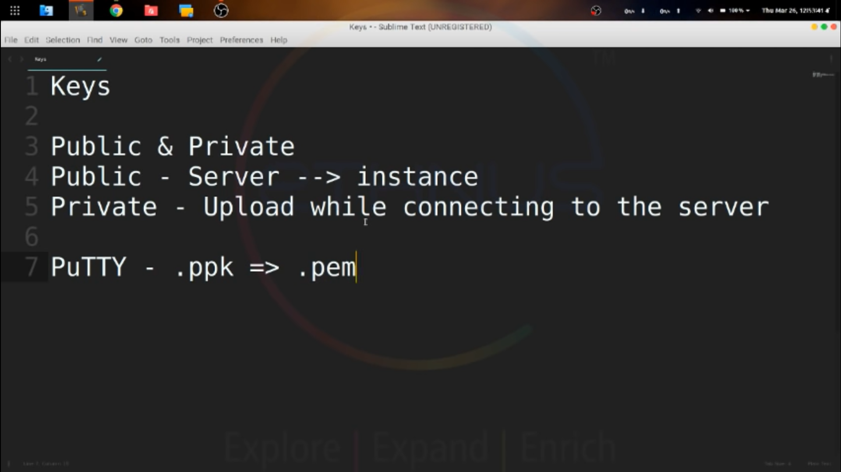

PUTTY ACCEPT PRIVATE KEY IN .PPK FORMAT SO WE HAVE TO CONVERT .PEM TO .PPK

WE CAN DO THE FOLLOWING BY USING PUTTYGEN SOFTWARE

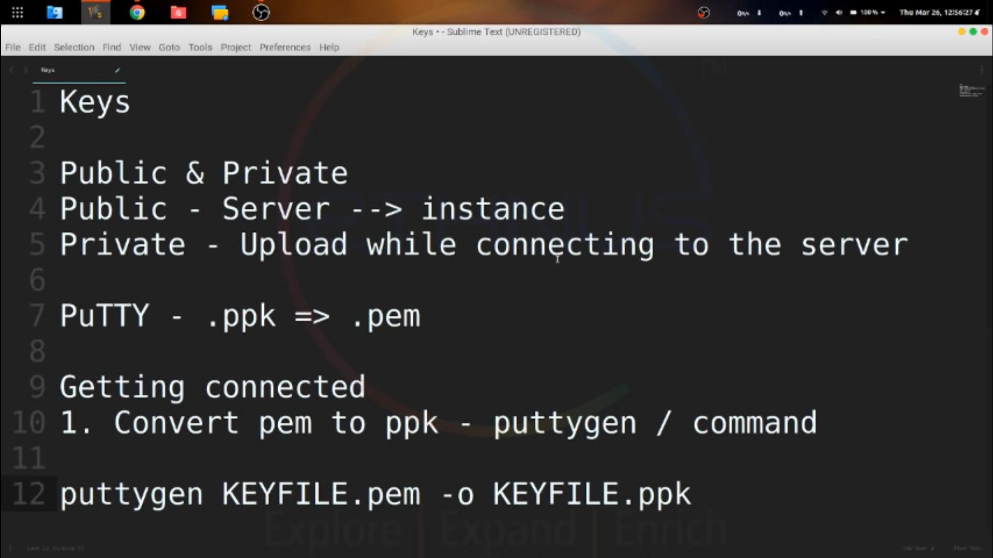

**What Is the .Pem File Format?**

**Privacy-Enhanced Mail (PEM)** file extension is a format that is mainly used to transmit data, certificates, email and cryptographic keys privately. The PEM file format is a tamperproof and secure way of storing and transferring data.

As a ‘.pem file’ can store multiple types of data; it represents data with appropriate suffix. While the most common is .pem suffix, others include .key for private keys and .cer or .crt for certificates. The PEM file format encodes it with the binary-to-text encoding scheme – base64 so that it represents binary data in ASCII string.

Even though the technological advancements have led to a more secure alternative to PEM container, it is still leveraged to store public and private certificates, root certificates and many others.

Unlike most file formats that are easy to convert via online conversion tools, a user requires a specific application to convert files that have .pem extensions. PuTTYgen is one such application that quickly converts f **.pem files to .ppk**.

**Convert .Pem to .Ppk using PuTTYgen**

The primary requisite is to download and [install PuTTY](https://www.puttygen.com/download-putty) application. As part of the networking client, PuTTYgen does not have to be downloaded separately. Users must download the latest version of the app and install the entire suite. Once installed, PuTTYgen will be ready to convert .pem files to .ppk format. We will provide detail steps to convert files on both operating systems – Windows and Unix.

**Converting .Pem to .Ppk on Windows**

1. Click on Start menu> All Programs > PuTTY > PuTTYgen.

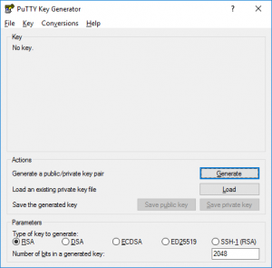puttygen-window

1. The following window will present with options on the crucial a user wants to generate. Select the option ‘RSA (Rivest–Shamir–Adleman). RSA is a public-key cryptosystem that is commonly used to transmit data securely. Users with an older version of PuTTY should select the option – ‘SSH-2 RSA.’

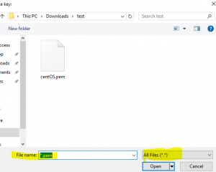Load .PEM file to puttygen

1. Next, click on the option ‘Load.’ As PuTTY supports its native file format, it will only show files that have .ppk file extension. Therefore, users have to choose the ‘All Files’ option from the drop-down bar. It will display all key files included the .pem file.

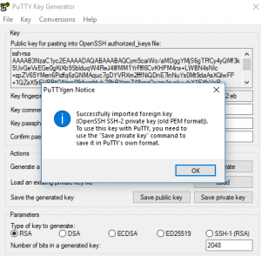save private key

1. Now, select the .pem file that you want to convert. As aforementioned that PuTTYgen is used for SSH connectivity, so it crucial for users to select the specific file that they plan to convert and click ‘Open.’ To confirm, click on ‘OK.’
2. In the resultant window, click on ‘Save private key’ which will convert and save the key file in PuTTY compatible format.
3. PuTTYgen will prompt a warning of saving the key without a passphrase. Hit ‘Yes’ on it.

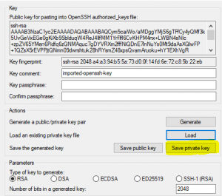save private key

1. Now, give the name to your file and PuTTYgen will automatically add .ppk file extension.

Note – Passphrases provide extra protection, but it sometimes gets annoying as each time a user copies files they have to enter the passphrase. Although, it entirely depends on the user if they wish or don’t wish to add the extra layer of protection

Once the file is converted to PuTTY compatible format, users can connect their local machine with remote servers.

**Converting .Pem to .Ppk on Unix or Linux**

To convert the file on Unix is far simpler than Windows. Users are first required to install PuTTY application on their Unix machines. Once done, all a user must do is enter a one-line command. First, run the [PuTTYgen command](https://www.puttygen.com/ssh-commands) and type the below-written command:

*$ sudo puttygen pemKey.pem -o ppkKey.ppk -O private*

Voila! The .pem files will quickly be converted to PuTTY native file format. Users can connect via PuTTY to remote servers from local systems using the newly created .ppk files on both Windows and Unix.

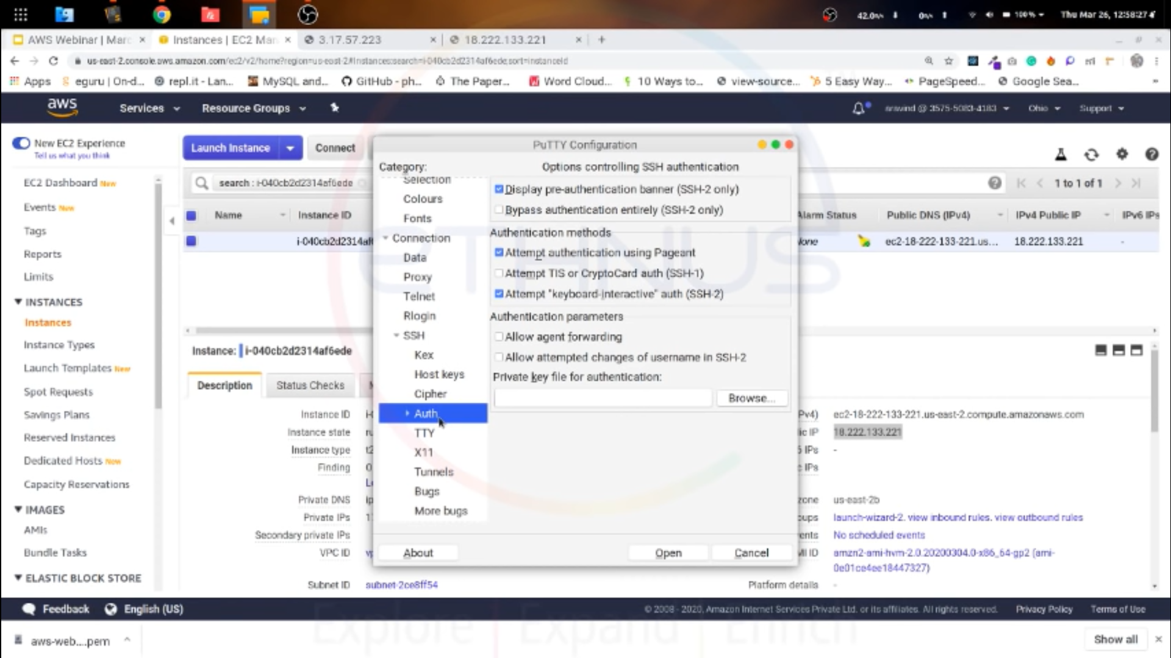

GO TO AUTH AND UPLOAD THE PPK FILE

1. SETUP AN APPACHE SERVER WITH FOLLOWING COMMANDS



1. AS BY DEFAULT THE EC2 ALLOWS ONLY SSH PORT 22 TRAFFIC AND WE MADE A APPACHE SERVER HTTPD SO TO ALLOW THE HTTP TRAFFIC AT PORT 80 WE NEED TO DO FOLLOWING

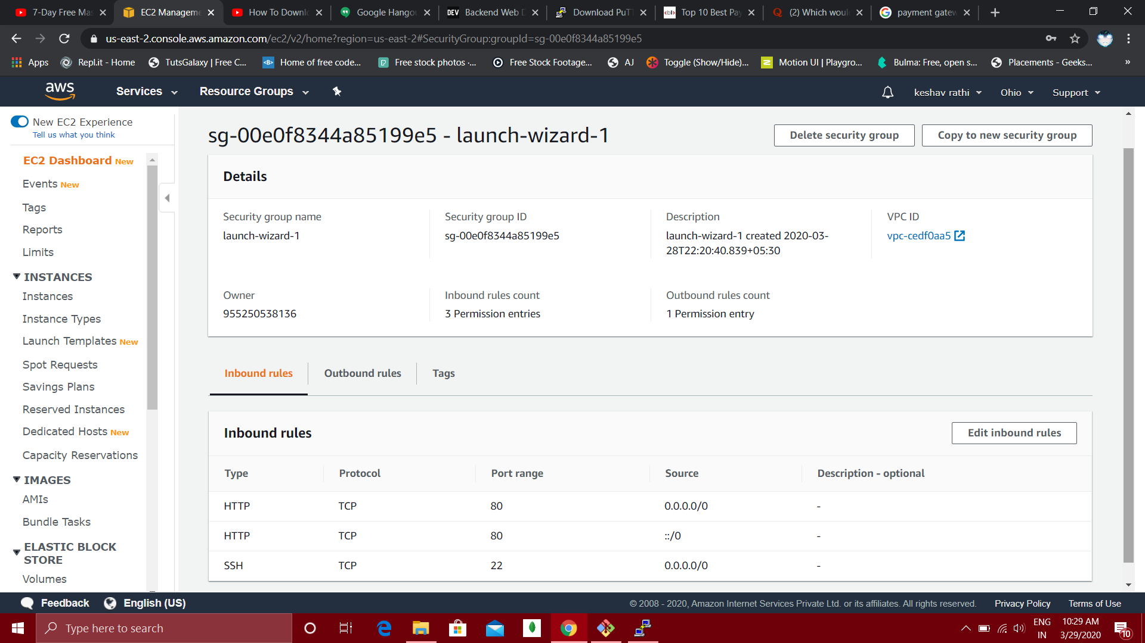

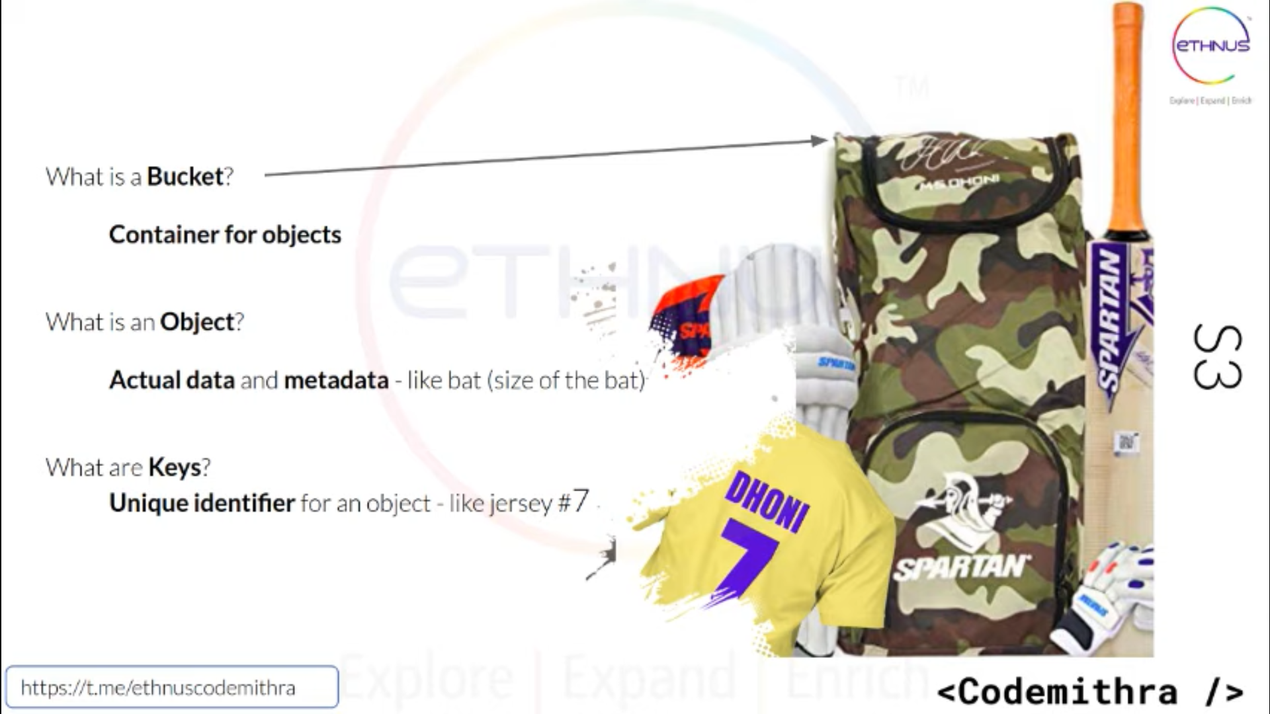

​EBS acts like your hard disk, connected to your machine. S3 acts like Google Drive or Dropbox, outside of your machine environment

S3 BUCKET:

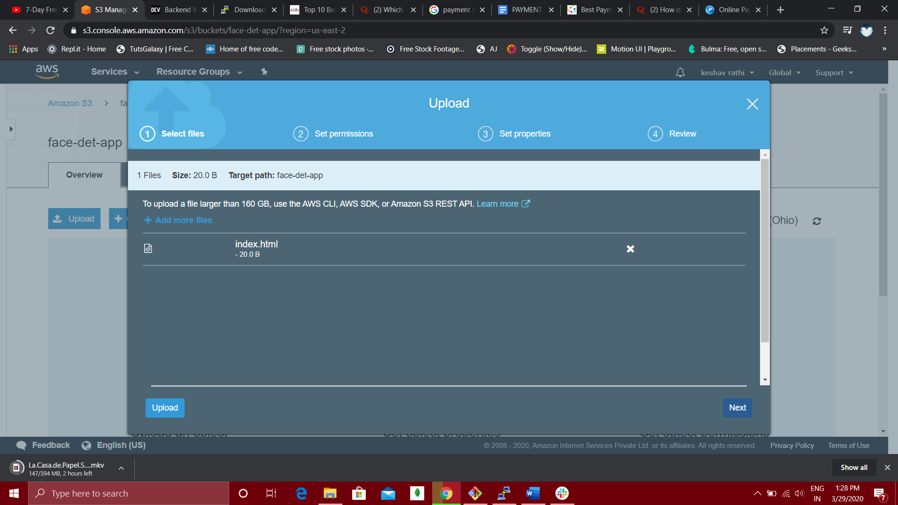

UPLOAD FILE

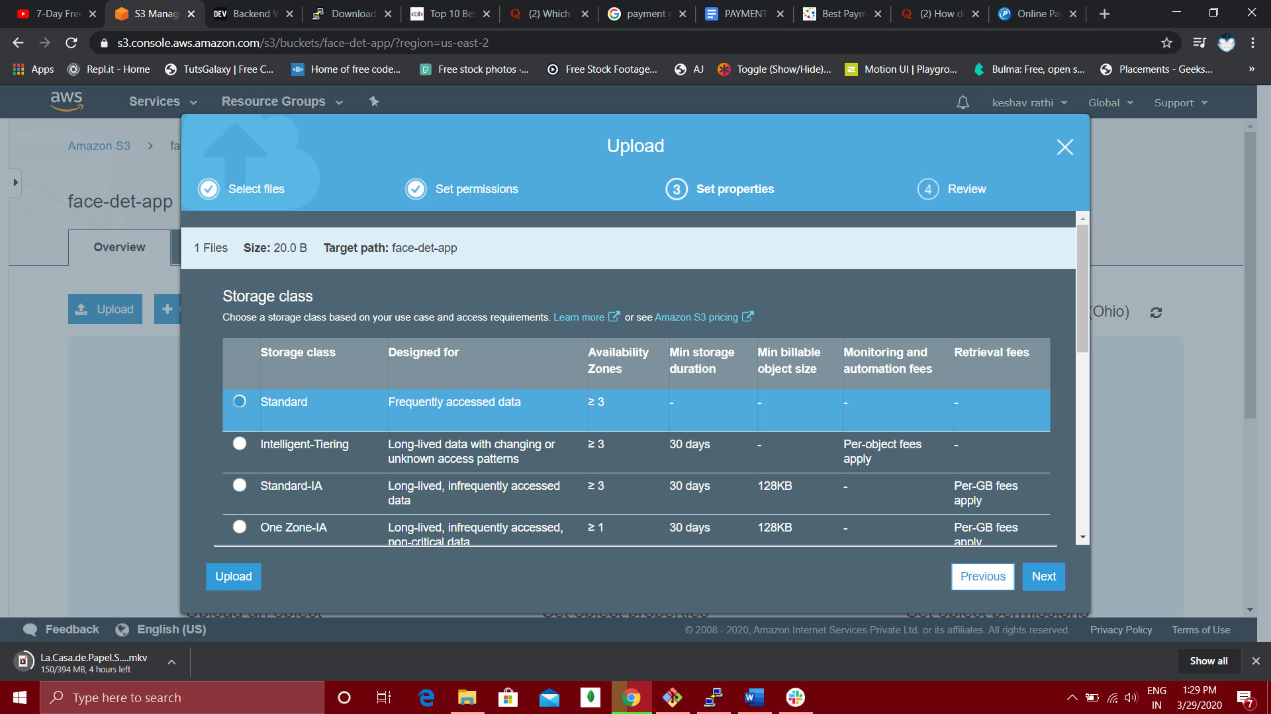

STANDARD FILE

DATA STORED IN S3:

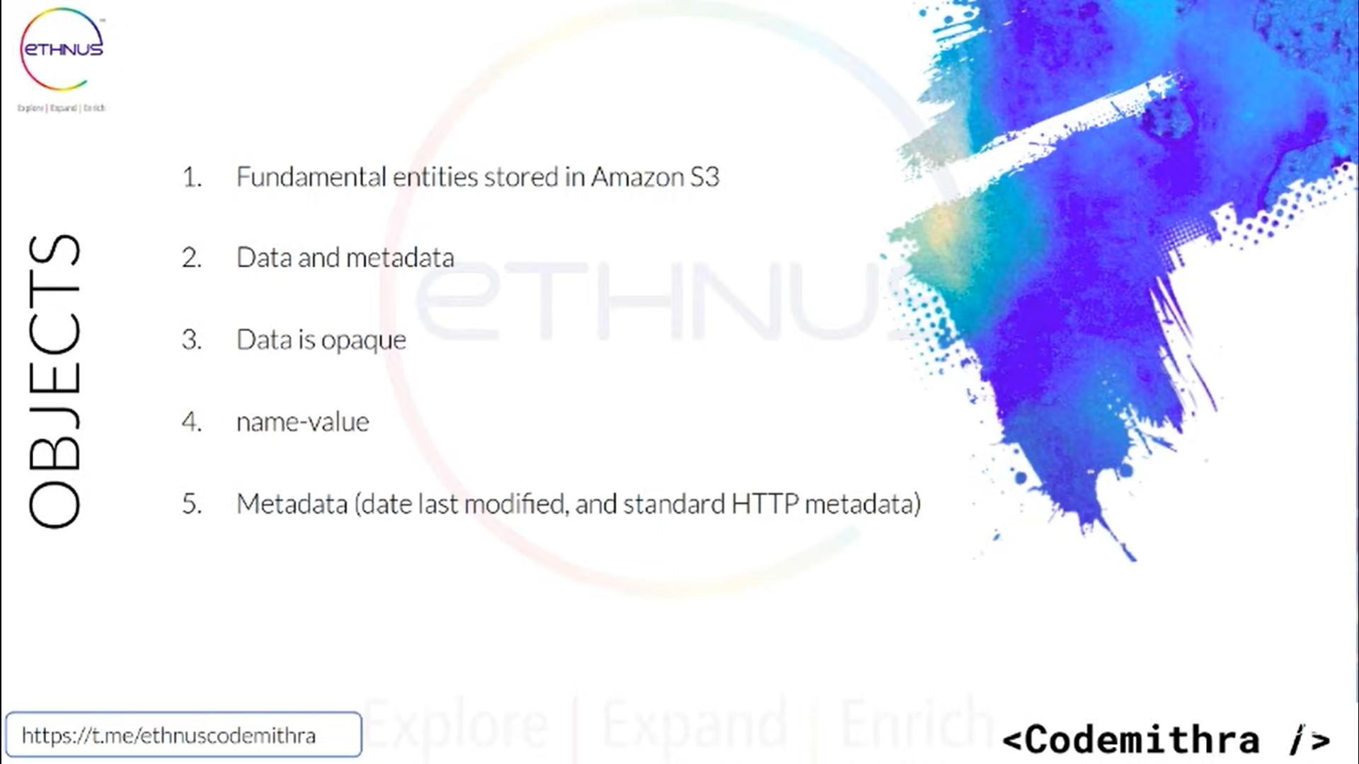

NOW TO HOST A S3 BUCKET WE NEED TO:

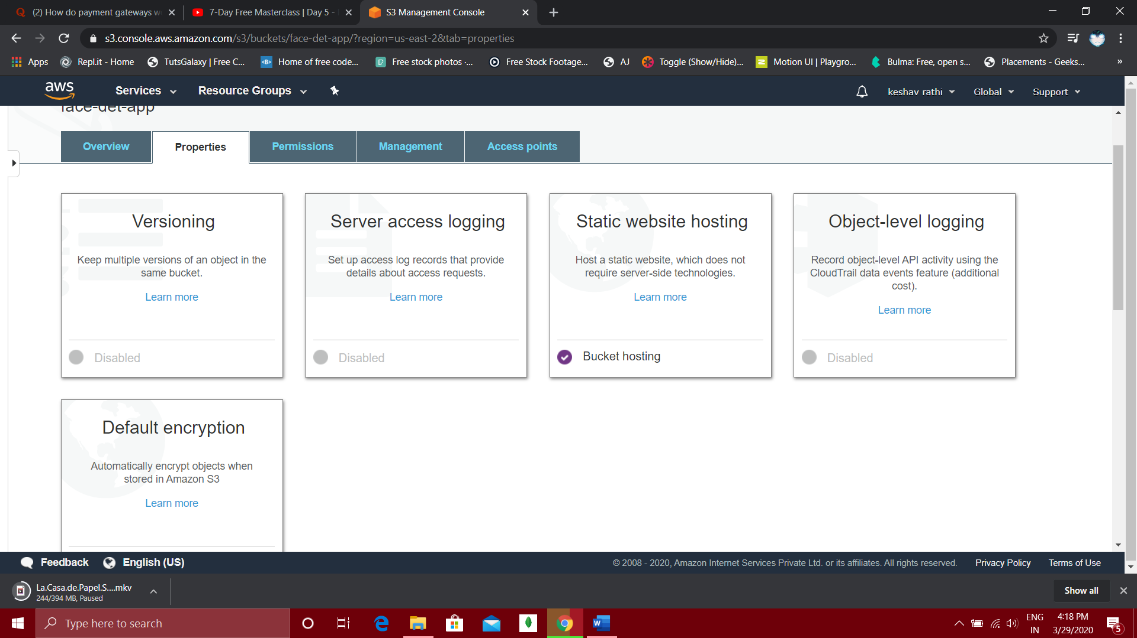

GO TO STATIC WEBSITE HOSTING AND NAME THE DOCUMENT WHICH WE WANT TO HOST

BY DEFAULT THE PUBLIC ACCESS FOR THE BUCKET MIGHT BE BLOCKED SO WE NEED TO MAKE IT PUBLIC

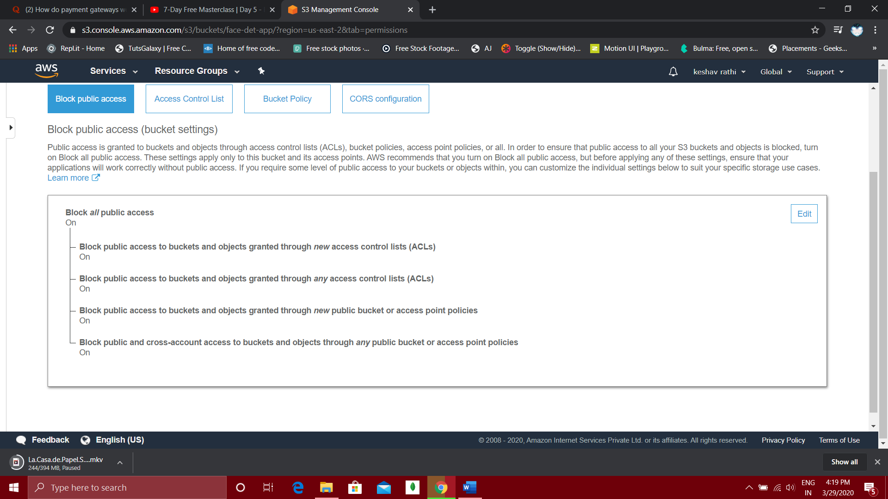

AND EVEN OUT BUCKET OBJECT WILL BE PRIVATE SO WE NEED TO MAKE IT PUBLIC TOO BY CLICKING

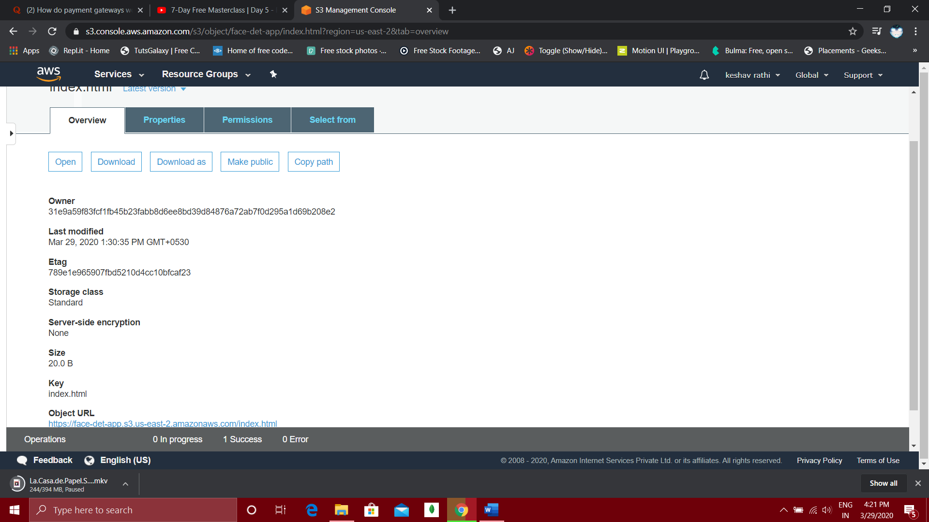

MAKE PUBLIC OPTION

VPC:



AMAZON TAKE A PART OF PRIVATE CLOUD AND CALL IT VIRTUAL PRIVATE CLOUD, IT’S A PUBLIC CLOUD BUT INSIDE THE PUBLIC CLUD THERE WILL BE A SMALL PART OF IT WHICH IS CALLED AS PRIVATE CLOUD

IT IS NOT PHYSICALLY ISOLATED BUT LOGICALLY ISOLATED

SUBNETS:

